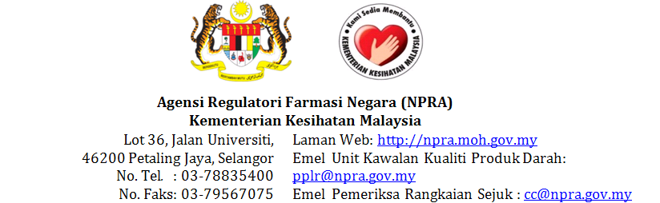
PLASMA PRODUCT LOT RELEASE APPLICATION FORM
- APPLICANT INFORMATION
1.1 Name & Address of
Product Registration Holder
1.2 Name & Address of
Importer
1.3 Name & Address of
Warehouse
1.4 Contact Person
1.5 Contact no.
- PLASMA PRODUCT INFORMATION
  - Name of plasma product
(as registered in Quest system)
2.2 Ingredients & strength
2.3 Name of manufacturer
2.4 Name of other manufacturer (If any)
2.5 MAL no. |  |  |  |  |  | 2.6 Lot no. of plasma product
2.7 Date of manufacture |  |  |  |  |  | 2.8 Expiry date
2.9 Storage condition |  |  |  |  |  | 2.10 Types of final container plasma product  ☐ Vial☐ Prefilled syringe  ☐ Ampoule  ☐ Others; please specify _______________________________
- DILUENT INFORMATION (IF ANY)
3.1 Name of diluent |  |  |  |  |  | 3.2Lot no. of diluent
3.3 Date of manufacture |  |  |  |  |  | 3.4 Expiry date
3.5 Storage condition |  |  |  |  |  | 3.6 Types of final container for diluent  ☐ Ampoule  ☐ Prefilled syringe
- QUANTITY OF PLASMA PRODUCT IMPORTED
4.1 Quantity in primary packaging |  |  |  | 4.2 Quantity in secondary packaging |  |  |  | 4.3 Total no. of doses per shipment
- TRANSPORTATION OF PLASMA PRODUCT
5.1 Arrival date |  |  |  |  |  | 5.2 Transit point (if any)
5.3 Route of transportation  ☐ Air  ☐ Ocean |  |  |  |  |  | 5.4 Mode of transportation  ☐ Active system  ☐ Passive system
- DOCUMENTATION
6.1 Documents submitted | ☐ Lot Summary Protocol  ☐ Lot Release Certificate  ☐ Certificate of Analysis of Finished Product  ☐ Importing Packing List  ☐ Air Way Bill / Sea Way Bill
- REDRESSING / REPACKING/RELABELLINGINFORMATION
(ONLY APPLICABLE FOR MAL NO. WITHOUT SUFFIX -R)
7.1 Do these product require redressing/repacking/ relabelling?  ☐ Yes. Refer to 7.2  ☐ No |  |  |  |  |  | 7.2 Have you submitted a request letter to conduct ANY redressing/repacking for these products to the Regulatory Coordination Section, Centre for Product Registration (SKR PPP)?  ☐ Yes. Submission date: _______________________________  ☐ No
The Malaysian Drug Registration Guidance Document defines redressing, repacking and relabelling as a manufacturing activity. Manufacturing of products without a valid manufacturing license is an offense under
Control of Drugs and Cosmetics Regulations 1984 [Regulation 12(1)]
- APPLICANT DECLARATION
I hereby certify that the above information given are true and correct as to the best of my knowledge.
I understand that if any of the above information is found to be false or untrue or misleading or misrepresenting, I am aware that I may be held liable for it, this application will be rejected and any payments made will not be refunded.
Remarks
Name |  |  | Signature |  |  |  | Date
FOR OFFICE USE ONLY
PPLR Documents complete? |  |  | ☐ YES |  |  |  | Received by, date & signature
☐ NO. List of pending documents:
☐ LRC ☐ COA ☐ AWB/SWB
☐ Importing Packing List
SAB Reference No.:  Bil( ) BPFK/PKK/16/04 |  |  | Amount:  ☐RM200  ☐RM500  ☐RM800 |  |  |  | Issued by, date & signature
Date of issuance:
Date of payment received: |  |  | Receipt no.: |  |  |  | Received by, date & signature

